Drukjegang Higher Secondary School is pleased to share the toppers (students scoring 80 % and above) and subject toppers of the school in BCSE 2021. School welcomes you to join any of the three streams of your choice; Science, Arts and Business & Entrepreneurship for Academic Year 2022 (Class XI).
PEMA YANGZOM
86.40 %
SONAM CHODEN
83.60 %
SONAM WANGCHUK
80.60 %
MONGALI MAYA SUBBA
87.00 %
DEENA TIMSINA
84.20 %
PURNI MAYA SUBBA
82.00 %
DHAN MAYA BISWA
89.80 %
PEMA YEDON
85.00 %
SABITA SUBBA
83.00 %

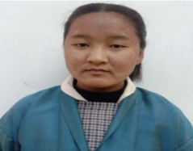
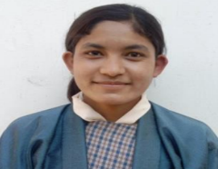
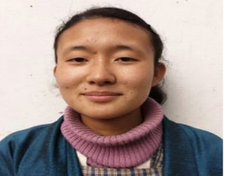

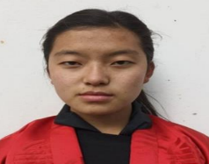
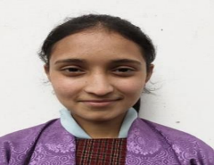
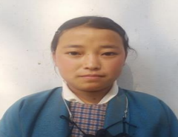

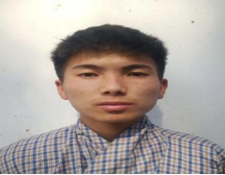
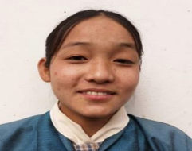
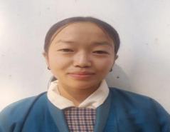

Overall Subject Toppers
Subject | Marks | Name
English | 85 | DHAN MAYA BISWA
Dzongkha | 84 | SONAM WANGCHUK
AGFS | 80 | MAYNAN OM GURUNG  SONAM WANGCHUK
EVS | 96 | DHAN MAYA BISWA
Biology | 89 | DHAN MAYA BISWA  PEMA YANGZOM
Chemistry | 91 | DHAN MAYA BISWA
Physics | 89 | MONGALI MAYA SUBBA
Geography | 87 | DHAN MAYA BISWA
History | 86 | MONGALI MAYA SUBBA
Mathematics | 85 | PEMA YANGZOM

A total of 72 students appeared for BCSE

